**Test Case** 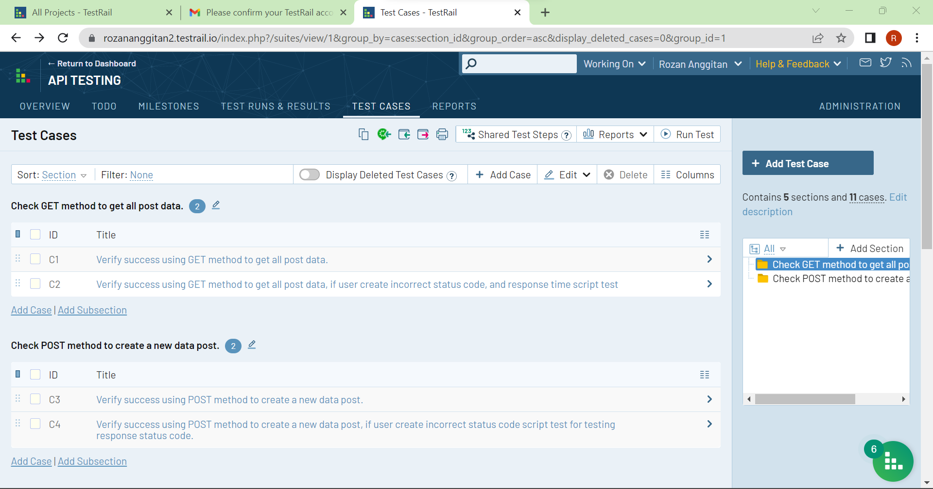

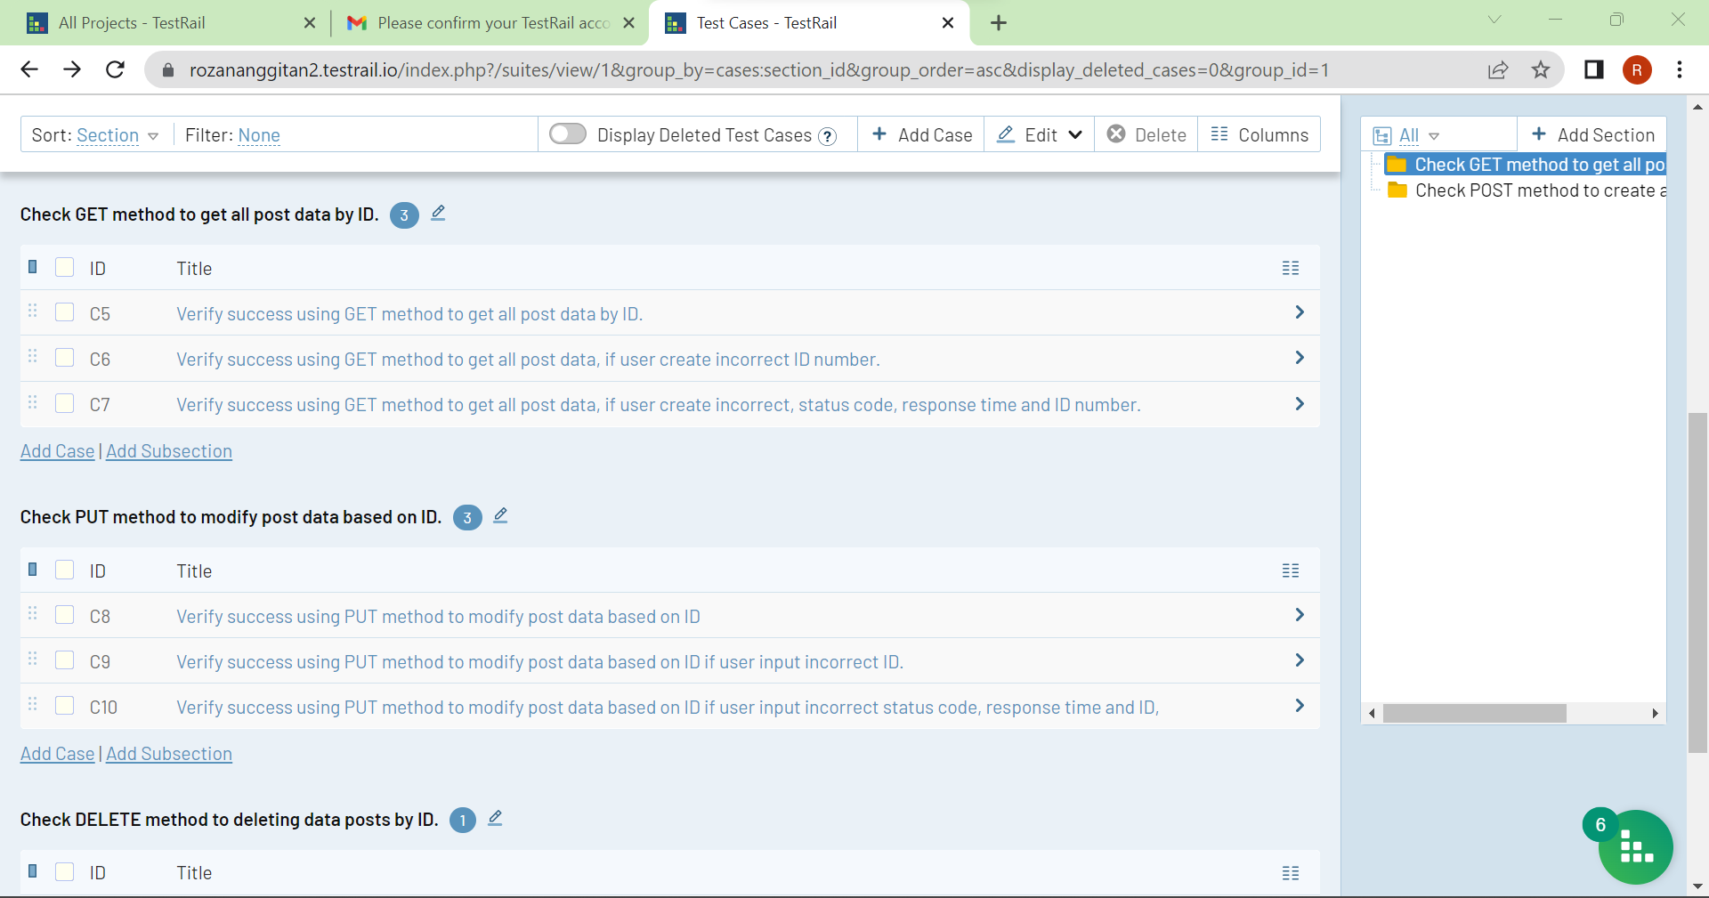

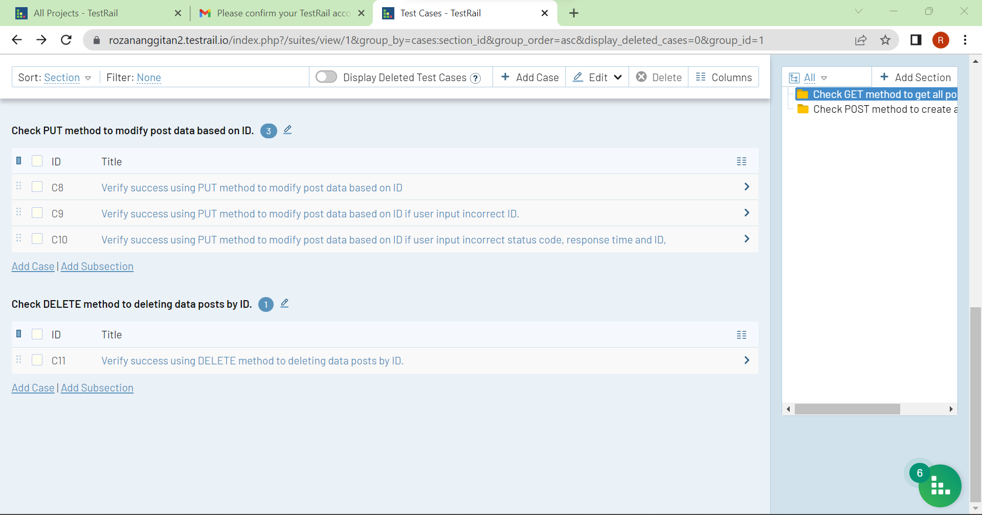

**Test Case : Verify success using GET method to get all post data.**

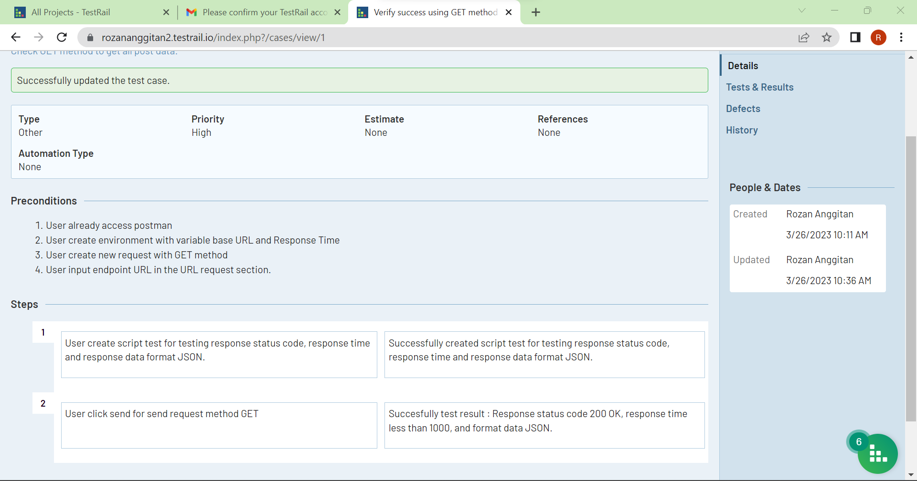

**Test Case : Verify success using GET method to get all post data, if user create incorrect status code, and response time script test**

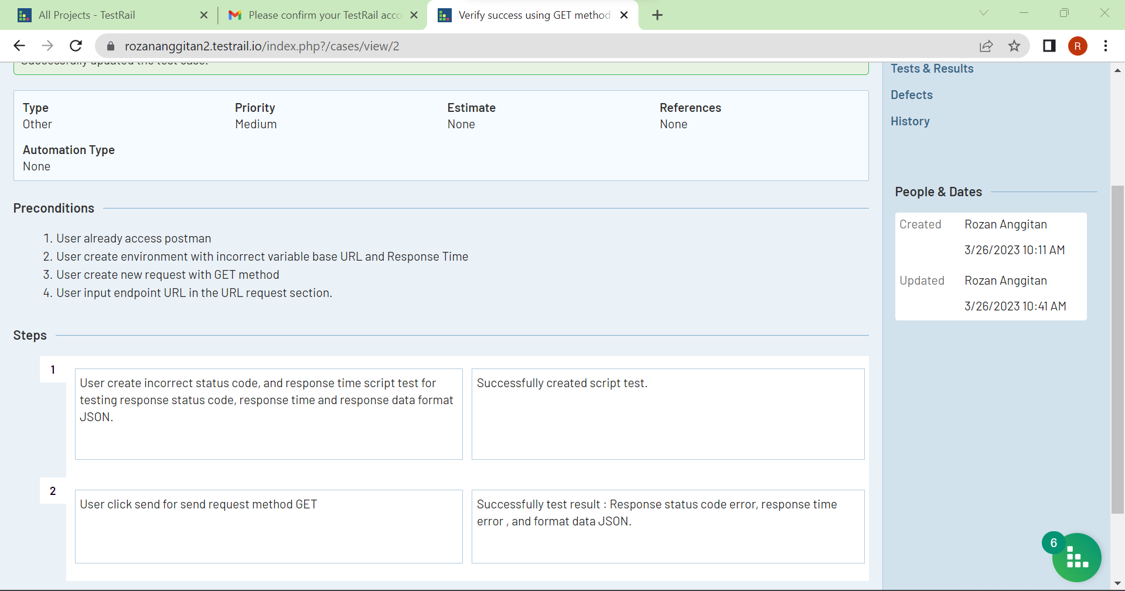

**Test Case : Verify success using POST method to create a new data post.**

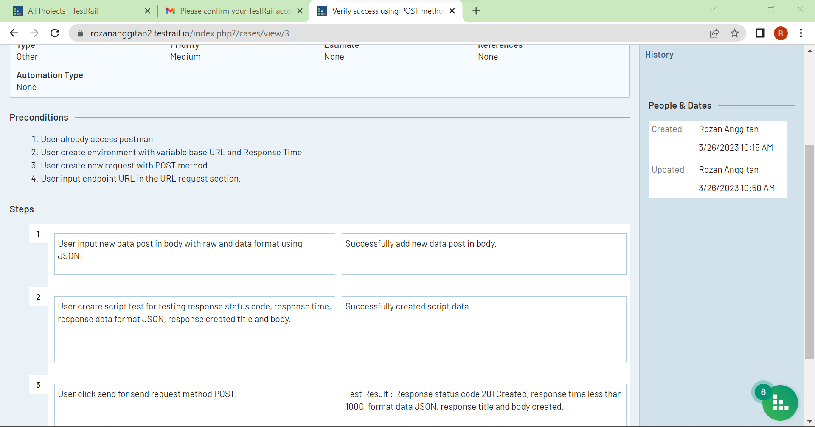

**Test Case : Verify success using POST method to create a new data post, if user create incorrect status code script test for testing response status code.**

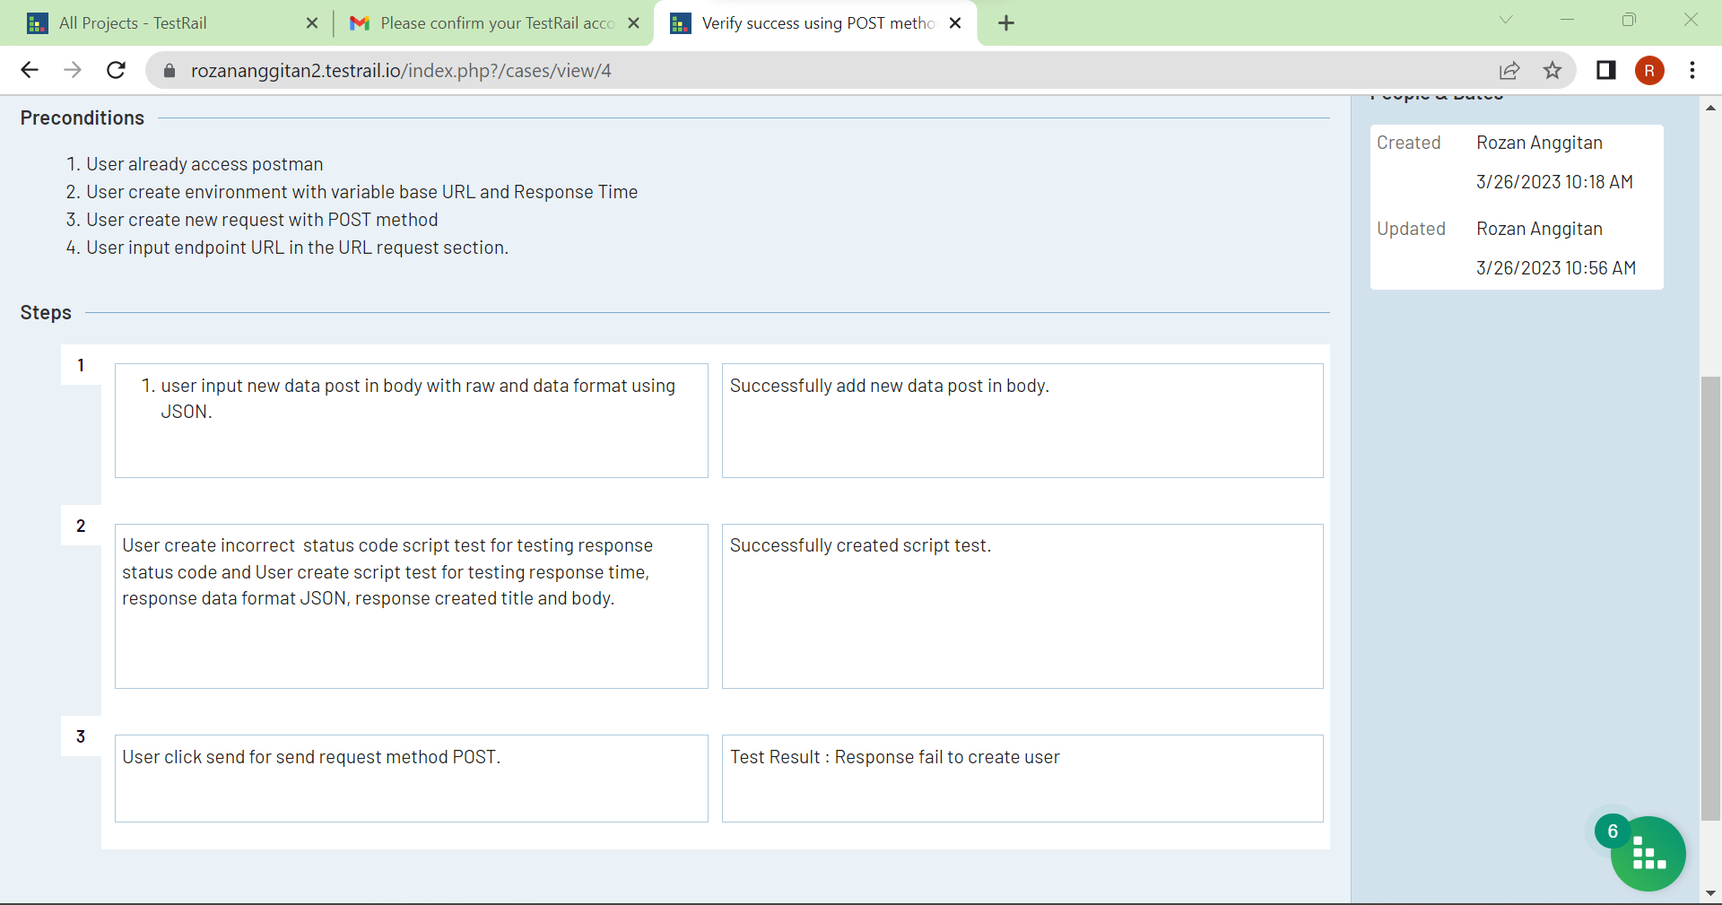

**Test Case : Verify success using GET method to get all post data by ID.**

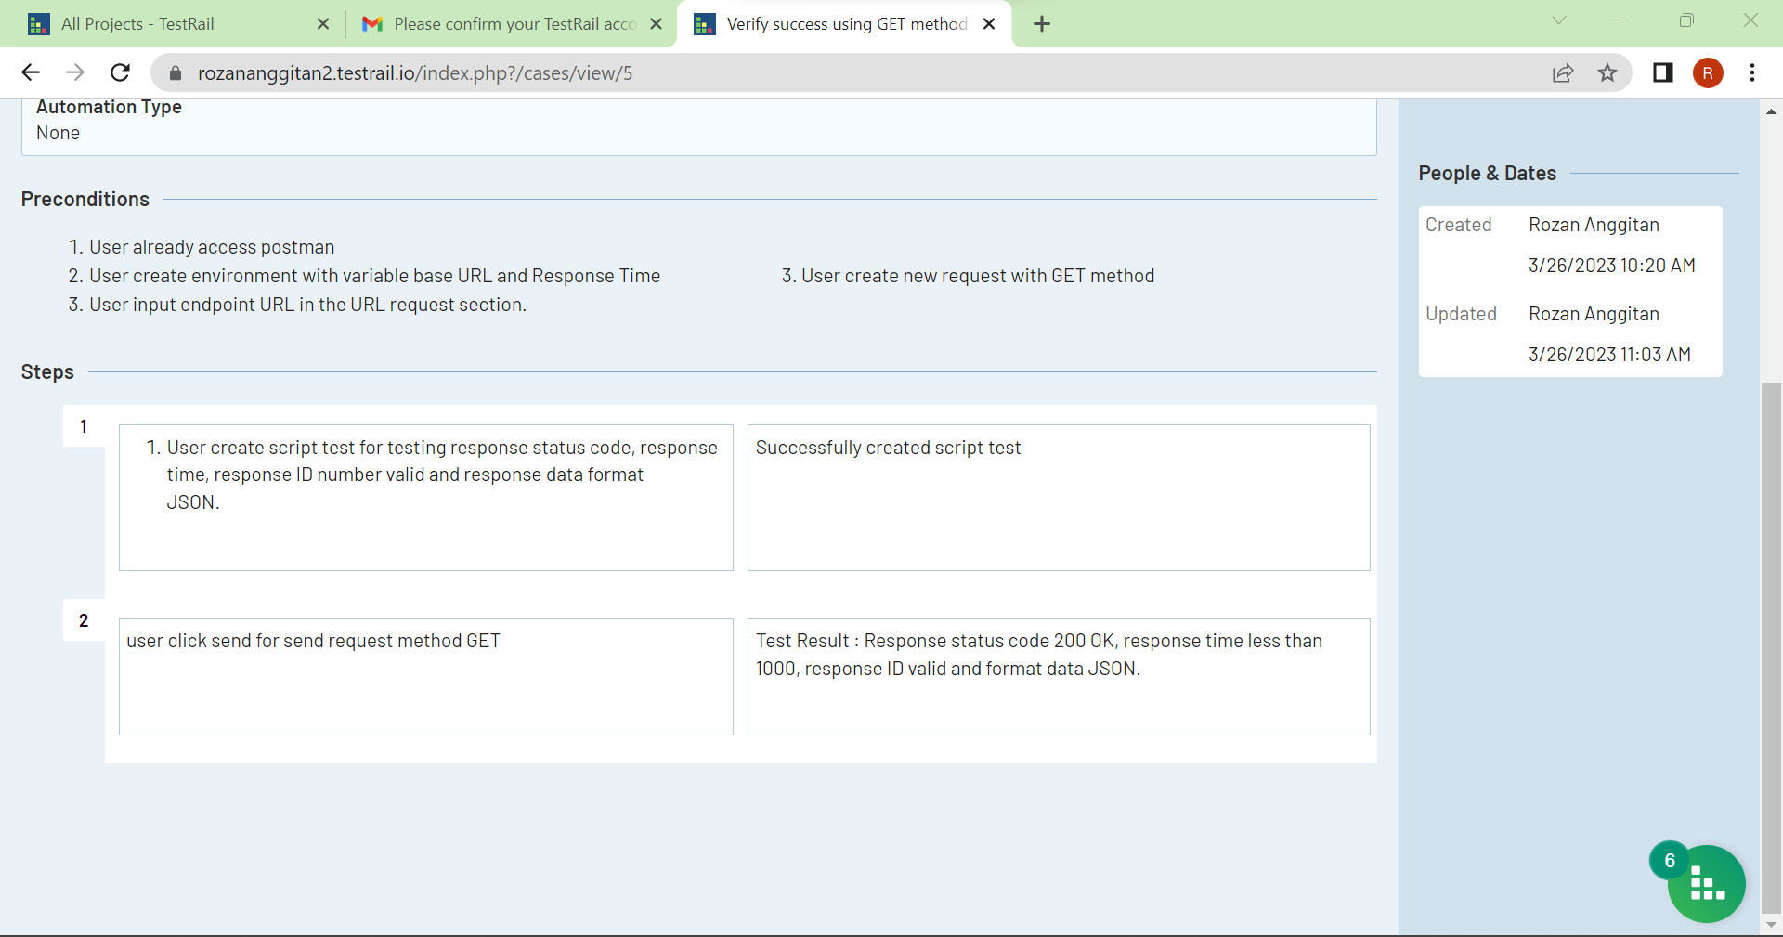

**Test Case : Verify success using GET method to get all post data, if user create incorrect ID number.**

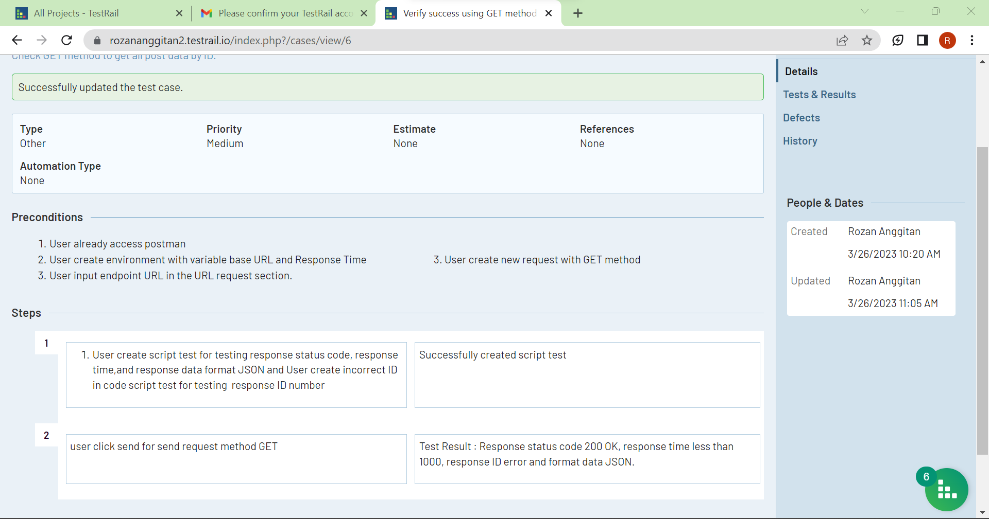

**Test Case : Verify success using GET method to get all post data, if user create incorrect, status code, response time and ID number.**

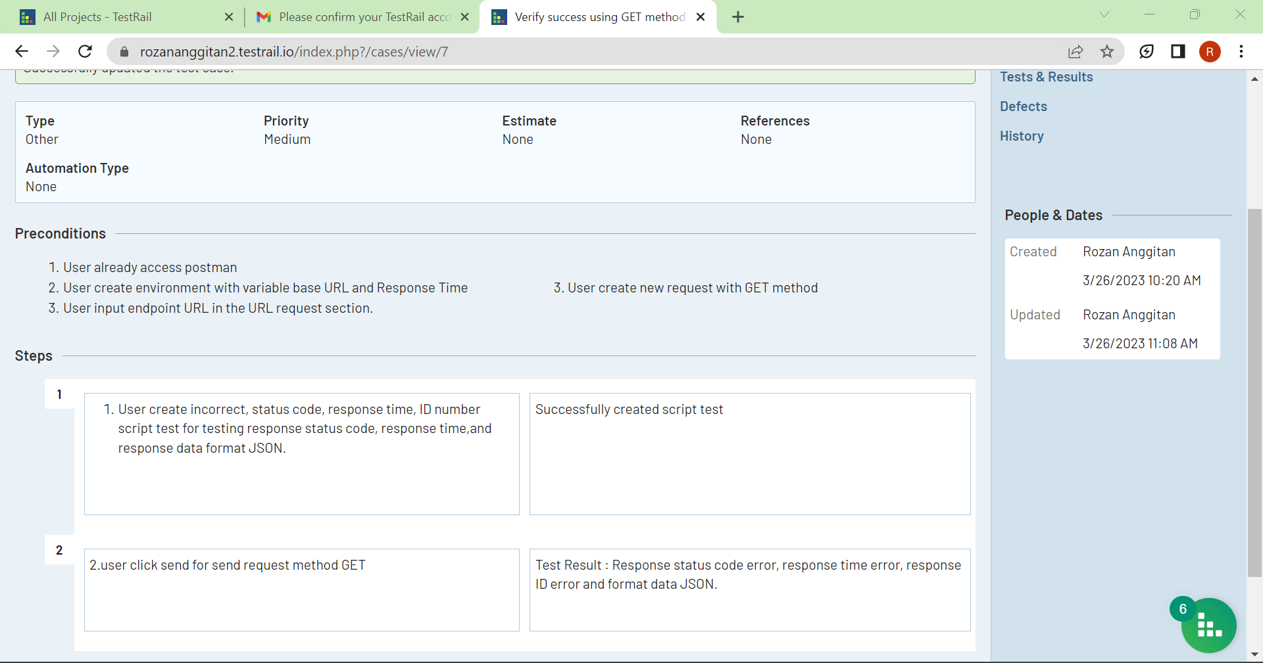

**Test Case : Verify success using PUT method to modify post data based on ID**

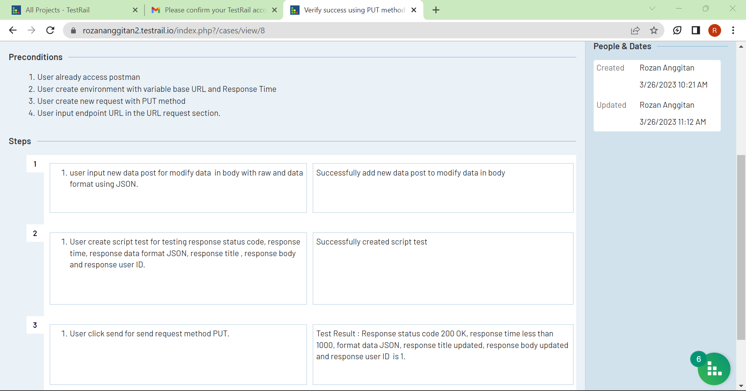

**Test Case : Verify success using PUT method to modify post data based on ID if user input incorrect ID.**

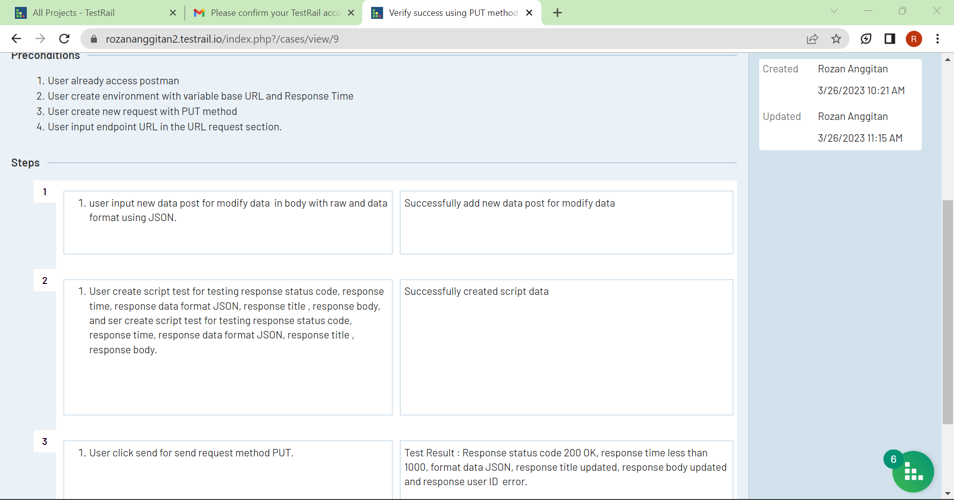

**Test Case : Verify success using PUT method to modify post data based on ID if user input incorrect status code, response time and ID,**

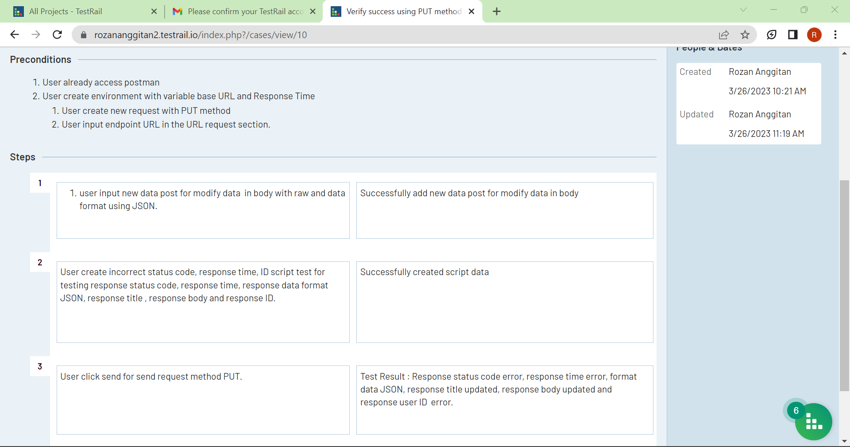

**Test Case : Verify success using DELETE method to deleting data posts by ID.**

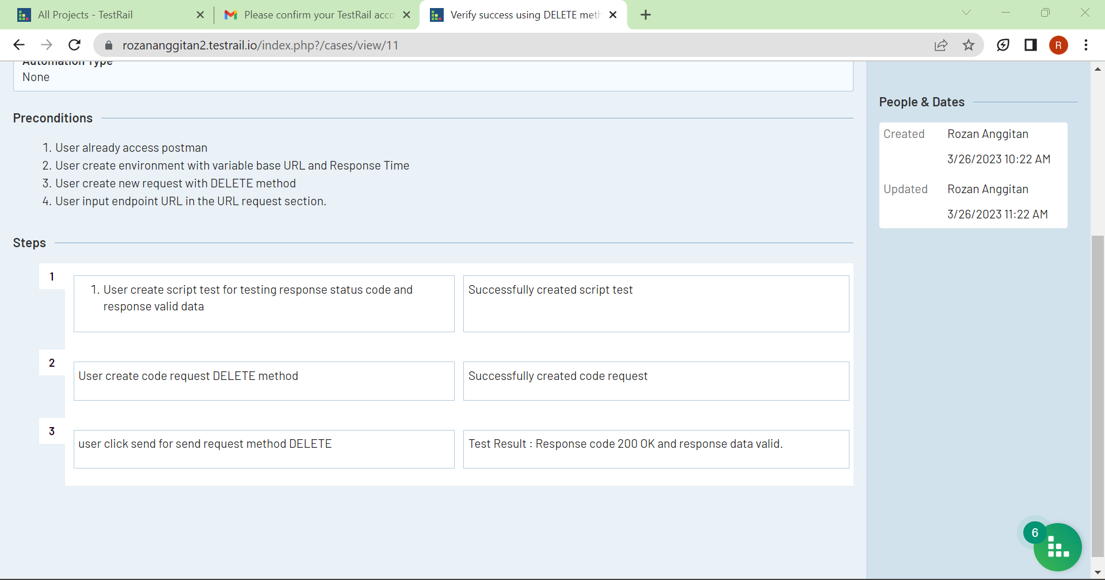

**TEST RUN**

